Press Release

CropLife India Welcomes the one year extension of interim approval of already approved agrochemicals
New Delhi, 26th April 2024: The Ministry of Agriculture and Farmers’ Welfare had released a memorandum on 18th April 2022, listing interim approved pesticides to be used for spraying by a drone. The registered pesticide formulations comprising of insecticides, fungicides and plant growth regulators (PGR’s) (including bio-pesticides and botanical pesticides) which otherwise are permitted to be sprayed manually by knapsack sprayers in India have been provisionally approved for commercial use through drones for a period of 2 years.

The crop protection industry has been seeking an extension of the approval so that, the ongoing impetus to the use of Drones in agriculture shall continue.

The Ministry of Agriculture has now given an extension of one year, i.e. up to 18th April 2025.

On this occasion, Mr. Durgesh Chandra, Secretary General, CropLife India shared, “CropLife India welcomes the move by the Ministry and feels that this will go a long way in boosting the agrochemical infrastructure and specially provide a boost to the Drone Didi scheme. The Drone technology helps in immense water savings along with being a step towards precision agriculture”.

Mr. Chandra added, “CropLife India, as the largest among all Indian agrochemical industry associations; and has been advocating the need for fast tracking drone’s application for spraying of agrochemicals since the year 2019. The discussions held during the Virtual Conference on Drones Application Technology in Spraying for Crop Protection was organized on 29th July 2020 and the Technical Discussion Paper on Drone Usage for Agrochemical Spraying was greatly appreciated in the consultation process. CropLife India was part of the Expert Committee formed by the Government of India for drafting of SOP for applying pesticides for crop protection and soil nutrients using drones with help from Japan's Drone Guidelines”.

About CropLife India:
CropLife India is committed to advancing sustainable agriculture and it is an association of 16 R&D driven member companies in crop protection. We jointly represent ~ 70% of the market and are responsible for 95% of the molecules introduced in the country. Our member companies have annual global R & D spend of 6 billion USD and are firmly committed to engaging with the farming community to enable Safe, Secure Food Supply.
Our member companies were established in India as far back as the 1950s; we continue to work hand-in-hand with the Government to build the agriculture sector – from direct investment of building factories, jobs creation, bringing in agriculture innovation and working endlessly over the years with multi-stakeholders to enhance agriculture productivity.

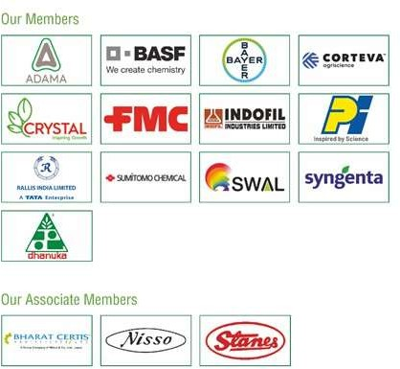

For more information, contact:
Mr. Joydeep Chakraborty Mobile: (0) 9711306346
E-mail: communications@croplifeindia.org Website: www.croplifeindia.org

