CropLife India conducts workshop on “Innovative Technologies in Crop Protection” in Telangana
Adoption of IPM & Kisan Drones in the year of Millets were the focal points
FPOs targeted for effective knowledge transfer and wider outreach

Warangal, Telangana 17th February 2023: CropLife India, an association of both Indian and Global R & D driven crop science organizations, and the leading voice of the plant science industry in India, pioneered a workshop on “Innovative Technologies in Crop Protection” in Telangana. The workshop was organized jointly with Foundation for Agriculture Sustainability and Transformation (FAST) and CropLife India. A demonstration of Kisan Drones and its advantages in agriculture along with discussion on Importance of Millets for Producer & Consumer, were integral part of the workshop.

The workshop was held in Warangal today; Ms. Usha Dayal, District Agriculture Officer, Warangal; being the Chief Guest. Dr. Damodhar, Principal Scientist, RARS, Warangall; Mr. Ramchander Rao Jojula, Asst. Director of Agri (R), FAST Associate; Mr. P. Sarangam, Asst. Director of Agriculture (R), Consultant-NFSC and Jaypal Reddy, Farmer Leader, Warangal, addressed the gathering. Apart from them, present on the occasion were national awardee farmers, officials of FAST, Scientists of Krishi Vigyan Kendra and Extension Officers, Farmer Producer Organizations (FPOs), CropLife India member companies and other officials.
Mr. Ramachandra Murthy P, President & Volunteer, FAST supported CropLife India to implement the event.

Ms. Usha Dayal, District Agriculture Officer, Warangal said, “With the introduction of Kisan Drones, they are becoming the Indian farmer's new best friend which would help in saving time, cost and increasing yield and productivity. The Centre and State Governments are taking all the necessary steps to facilitate the usage of drones.”

Ms. Dayal added, “The outreach effort being done by CropLife India towards Integrated Pest Management techniques like role of beneficial insects including pollinators; judicious and responsible use of crop protection products; secure storage of crop protection products; impacts of counterfeit and illegal products; use of PPE (Personal Protective Equipment); correct spraying techniques and triple rinsing of used containers; are highly beneficial for farmers”.

Mr. Durgesh Chandra, Secretary General, CropLife India shared, “We believe that with all the favourable policy support coming in from the Government, the conducive ecosystem needs to be nurtured in order to ensure faster adoption of drones in Indian Agriculture. All the ecosystem stakeholders- Government, Agricultural Universities, Research Institutions, Corporates, Industry Associations, Drone Training Institutes, Drones manufacturers, Drone service providers, FPOs, farmers, Agri & Rural Entrepreneurs, etc. will have to work in tandem towards achieving this”.

Mr. Chandra added, “Our member companies are exploring avenues for enhancing faster adoption of Kisan Drones. Hence, going forward, the demand for customised Drone-as-a-service models (Agricultural applications and Crop protection) is bound to rise by leaps and bounds. Early acceptance of Innovative Technologies in agriculture has enhanced relevance when India is poised to elevate the usage of Millets in the world”.

During the program, CropLife India distributed mini PPE kits and key Safe use messages pamphlets for quick reference & further dissemination.

CropLife India remains committed to advancing agriculture in India and to meaningfully engage with the Government and farming community; to enable Safe & Secure Food Supply. CropLife India assures of our full support in the interest of progressive and pragmatic initiatives of the Government for the benefit of Farmers and Sustainable Agriculture in India.

About CropLife India:
CropLife India is committed to advancing sustainable agriculture and it is an association of 16 leading domestic and international R&D driven member companies in crop protection and the leading voice of the plant science industry in India. We jointly represent ~ 70% of the market and are responsible for 95% of the molecules introduced in the country. Our member companies have annual global R & D spend of 6 billion USD and are firmly committed to engaging with the farming community to enable Safe, Secure Food Supply.

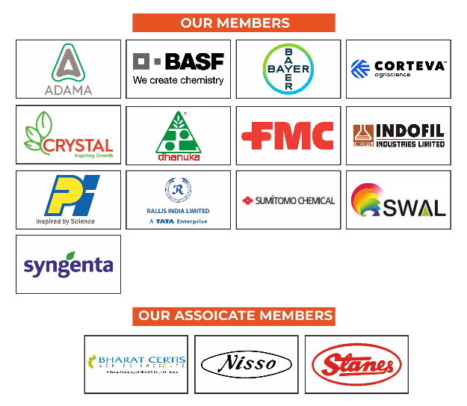

For more information, contact:
Mr. Joydeep Chakraborty
Mobile: (0) 9711306346
E-mail: communications@croplifeindia.org
Website: www.croplifeindia.org
Follow CropLife India on –
Facebook | Twitter | Youtube | Instagram | Linkedin

