PRESS RELEASE

CropLife India re-elects Dr K. C. Ravi as the Chairman and Mr. Anil Kakkar as the Vice Chairman and elects Mr. Ankur Aggarwal as the second Vice Chairman of CropLife India during its 43rd AGM

New Delhi, 12th October 2023: CropLife India; the association of leading domestic and multinational R&D driven crop science companies; is pleased to announce that Dr. K. C. Ravi, Chief Sustainability Officer, Syngenta India has been re-elected as the Chairman of the Board, 4th year in a row; during the 43rd Annual General Meeting held in New Delhi. Mr. Anil Kakkar, Vice President – Sales and Marketing, Sumitomo Chemical India was re-elected as the Vice Chairman, 3rd year in a row. Mr. Ankur Aggarwal, Managing Director, Crystal Crop Protection Ltd. has been elected as the second Vice Chairman of the Board by the members.

With his immense experience, Dr. Ravi would continue to lead the agenda of the crop protection industry in championing innovative technologies that enable farmers to sustainably increase productivity while managing the critical challenges facing our environment.

Dr. K. C. Ravi, shared, “As India emerges as a Global Food Hub, the need for a predictable, stable, and science-based policy and regulatory regime in the crop protection sector is imperative. As the Chairman of CropLife India, our unwavering commitment to working passionately for the betterment of Indian farmers; remain unhindered. We are dedicated to provide our farmers, with science-based, science-led, and science-bred products to ensure the effective and enduring protection of their crops”.

Mr. Durgesh Chandra, Secretary General, CropLife India shared, “CropLife India with the support of new Board will continue to engage with all the stakeholders for the growth of the agriculture sector and also of the crop protection sector. CropLife also continues to create awareness amongst the farmers for the safe and responsible use of crop protection solutions”.

Crop protection industry is one of the most important segments of the agriculture sector and contributes significantly in the socio-economic development of the farming community, rural economy and also to the Indian economy. CropLife members are committed to work closely with farmers, scientific community and policy makers to address current as well as future challenges and work towards bringing latest and safer innovations for the farmers. However, the cost of research has gone up and it is estimated that the cost of discovery and development of a new active ingredient is around INR 2000 crores. If Indian agriculture must flourish, be more competitive, quality driven, reducing wastages as well as losses to enable our farmers to be more successful, it is absolutely essential that a progressive policy environment is in place that fosters innovations.
About CropLife India:
CropLife India is committed to advancing sustainable agriculture and it is an association of 16 R&D driven member companies in crop protection. We jointly represent ~ 70% of the market

and are responsible for 95% of the molecules introduced in the country. Our member companies have annual global R & D spend of 6 billion USD and are firmly committed to engaging with the farming community to enable Safe, Secure Food Supply.

Our member companies were established in India as far back as the 1950s; we continue to work hand-in-hand with the Government to build the agriculture sector – from direct investment of building factories, jobs creation, bringing in agriculture innovation and working endlessly over the years with multi-stakeholders to enhance agriculture productivity.
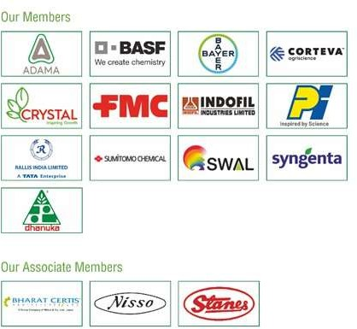

For more information, contact:
Mr. Joydeep Chakraborty Mobile: (0) 9711306346
E-mail: communications@croplifeindia.org Website: www.croplifeindia.org

