PRESS RELEASE

Indian farmers need newer & greener crop protection products

– CropLife India welcomes the interim Budget 2024-25 and stresses on the full Budget for the Agrochemical sector
New Delhi, 01st February 2024: CropLife India, an association of 16 R&D driven crop science companies, welcomed the interim Budget 2024-25 and shared that in order to enhance the focus on Innovation and Research & Development, which would help the farmers with newer and greener crop protection products; Provide 200% weighted deduction on R&D expenses by agrochemical companies; Follow a uniform basic customs duty of 10% for both Technical raw material and for Formulations and GST on agrochemicals be reduced from the current 18% to 12%.
Mr. Durgesh Chandra, Secretary General, CropLife India opines, "While the interim budget has focused on the growth done towards promotion of technologies and innovation in agriculture; the full Budget 2024-25 should look at reforms for augmenting the farmers’ income and overall growth of the sector. Indian farmers need newer & greener crop protection products. Formulation import of new for-India single molecules or their different combinations helps the farmers in combating resistance, climate change, new invasive pests and in improving the competitiveness of Indian agricultural produce internationally. Once these new solutions get adopted by the farmers, the local manufacturing commences and supports ‘Make in India’. Formulations Imports are then converted to the manufacture of formulation and then to manufacturing of the technical in India.”
Mr. Chandra added, “We would continue to urge the Indian Government to implement a science-based, progressive and predictive regulatory regime, for the sector to achieve its true potential.”
It’s time that full Budget 2024-25 should focus on the crop protection industry. CropLife India and its members would like to urge the Government to provide 200% weighted deduction on R&D expenses by pesticides companies; retain a uniform basic customs duty of 10% for both Technical raw material and for Formulations and reduce the GST on agrochemicals from the current 18% to 12%; all of which will directly benefit the farmers.

About CropLife India:
CropLife India is committed to advancing sustainable agriculture and it is an association of 16 R&D driven member companies in crop protection. We jointly represent ~ 70% of the market and are responsible for 95% of the molecules introduced in the country. Our member companies have annual global R & D spend of 6 billion USD and are firmly committed to engaging with the farming community to enable Safe, Secure Food Supply.

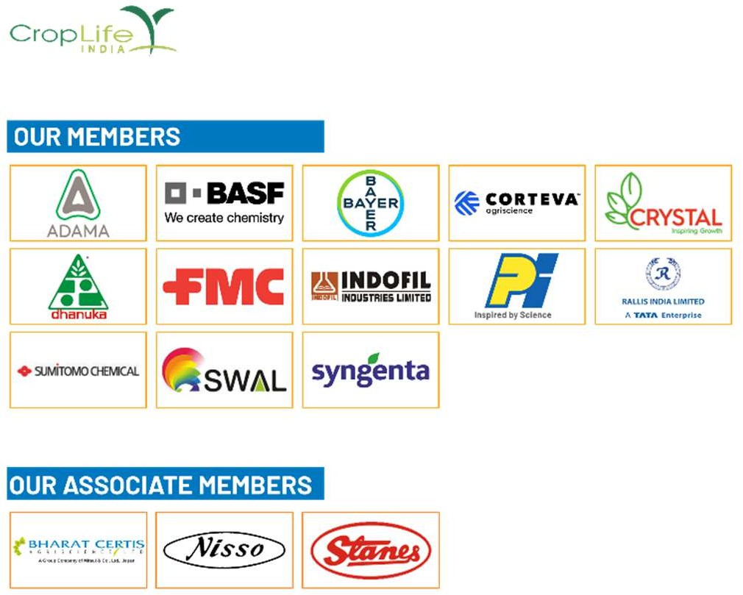

For more information, contact:
Mr. Joydeep Chakraborty Mobile: (0) 9711306346
E-mail: communications@croplifeindia.org Website: www.croplifeindia.org
Follow CropLife India on –
Facebook | Twitter | Youtube | Instagram | Linkedin

