PRESS RELEASE

CropLife India welcomes Union Budget 2023-24 and applauds the Government for initiating the digital public agri infrastructure for aiding the crop protection industry
Another step towards youth entrepreneurship and strengthening Indian Agriculture after Drones for agrochemical spraying
New Delhi, 01st February 2023: CropLife India, an association of 16 R&D driven crop science companies, and the leading voice of the plant science industry in India, compliments the Government of India for initiating the development of a robust digital public infrastructure in the agriculture industry for aiding the crop protection industry in the Union Budget 2023-24. This will enable inclusive farmer-centric solutions through relevant information services, for crop planning and health, improved access to farm inputs, credit and insurance, help for crop estimation, market intelligence and support for the growth of agri-tech startups.

An Agriculture Accelerator Fund will be set up to encourage formation of agri-startups by young entrepreneurs in rural areas. The fund will aim at bringing innovative and affordable solutions for challenges faced by farmers. It will also bring in modern technologies to transform agricultural practices and increase productivity and profitability.

The Budget 2022-23 witnessed the inclusion of “Kisan Drones” for Agrochemical Spraying, crop assessment & digitization of land records. Kisan Drones is now fast emerging as the Indian farmers’ best friend and setting up of the digital public infrastructure would further boost Indian agriculture and provide a fillip to the digital ecosystem for agriculture.

Mr. Durgesh Chandra, Secretary General, CropLife India shared, "It is extremely delightful to witness the initiation of digital public infrastructure for agriculture aiding the crop protection industry in the Union Budget 2023-24. The Government’s push towards Digitalization of Agriculture coupled with the focus on Hi-Tech services would enhance rural entrepreneurship and infuse youth back in the farmlands, boosting the productivity”.

CropLife India and its members have been urging the Government to reduce the GST on agrochemicals from the current 18% to 12% and provide 200% weighted deduction on R&D expenses by agrochemical companies; both of which would have directly benefited the farmers.

About CropLife India:
CropLife India is committed to advancing sustainable agriculture and it is an association of 16 R&D driven member companies in crop protection and the leading voice of the plant science industry in India. We jointly represent ~ 70% of the market and are responsible for 95% of the molecules introduced in the country. Our member companies have annual global R & D spend of 6 billion USD and are firmly committed to engaging with the farming community to enable Safe, Secure Food Supply.

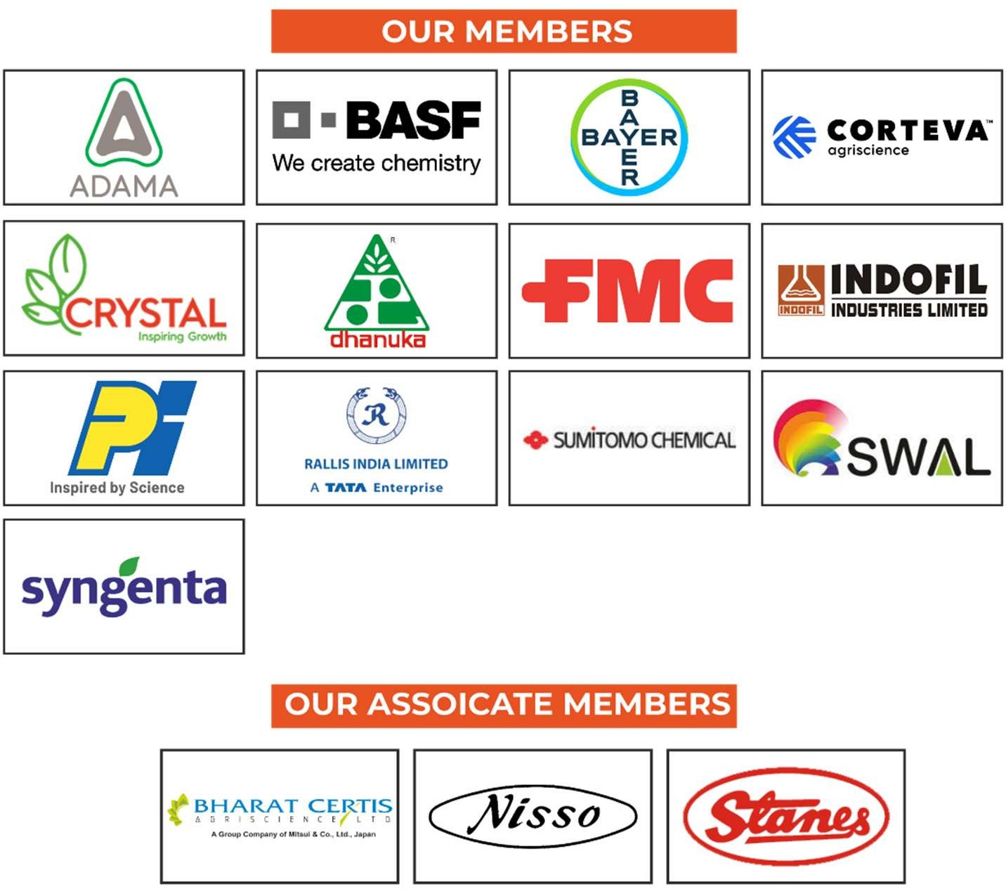

For more information, contact:

Mr. Joydeep Chakraborty Mobile: (0) 9711306346
E-mail: communications@croplifeindia.org Website: www.croplifeindia.org
Follow CropLife India on –

Facebook | Twitter | Youtube | Instagram | Linkedin

