**PRESS RELEASE**

Enhanced focus on farmers’ welfare via promoting Innovation and R&D in agrochemicals, uniform basic customs duty of 10% and reduction in GST

- Recommendations from CropLife India on the Union Budget 2023-24 for the Agrochemical sector

**New Delhi, 20th January 2023:** CropLife India, an association of 16 R&D-driven crop science companies, suggested that in order to enhance the focus on Innovation and Research & Development, which would benefit the farmer; *Follow a uniform basic customs duty of 10% for both Technical raw material and for Formulations*; *Provide 200% weighted deduction on R&D expenses by agrochemical companies and GST on agrochemicals be reduced from the current 18% to 12%.*

**Mr. Durgesh Chandra, Secretary General, CropLife India** opines, "In order to enhance the income of the farmers, **agriculture reforms** are the need of the hour and Budget 2023-24 will be an imminent step. Formulation import of new for-India single molecules or their different combinations helps the farmers in combating resistance, climate change, new invasive pests and in improving the competitiveness of Indian agricultural produce internationally. Once these new solutions get adopted by the farmers, local manufacturing can commence and support the larger objective of ‘Make in India’. Formulations imports are then converted to the manufacture of formulation and then to manufacturing of the technical in India.”

**Mr. Chandra** added, “Therefore the topic of imports needs to be looked at holistically and factually, and not with a narrow perspective so that stakeholders in the service of Indian Agriculture are not misguided with motivated claims and narrow perceptions. Keeping in mind the potential of the agrochemical industry, the Government has recognized Agrochemicals as one of the *12 Champion Sectors*, where India can become a major global manufacturing hub. However if we have to become a global hub for supplies, Indian regulatory processes must comply with the global regulatory ecosystem. We cannot have a dual policy of stifling formulations imports in India, yet promote export of formulations. We urge the **Indian Government to implement a science-based, progressive and predictive regulatory regime**, for the sector to achieve its true potential”.

**Our rationale –**

|  |  |  |
| --- | --- | --- |
| **Issue** | **CropLife India Recommendation** | **Justification** |
| Proposal for enhancement of Basic Customs Duty of pesticide formulation from 10% to 30% by some sections of industry. | * Follow a uniform basic customs duty of 10% for both Technical raw materials and for Formulations. | 1. If any restriction in Formulation import is imposed, India will be deprived of safer and newer formulations for the benefit of Indian farmers 2. The increase in basic customs duty from 10% to 30% will   have a huge impact on the |

|  |  |  |
| --- | --- | --- |
| **Issue** | **CropLife India Recommendation** | **Justification** |
|  |  | final pricing and will adversely affect the affordability of the smallholder farmer community in India.   * Please also note that most of the input for the smallholder farmers in India is zero duty for example seeds etc. Hence, an increase in the customs duty will impact smallholder farmers and it would be difficult for them to sustain in such a difficult situation. |
| Farmers are bearing high GST rate on agrochemicals but are unable to seek benefits. | * The GST rate on agrochemicals should be lowered to 12%. * The lower rate would be aligned with other agriculture inputs. * The lower rate would help in lowering the prices of agrochemicals. | * Farmers do not have any mechanism of claiming the input on taxes being paid by them; yet are susceptible to higher taxation. * The move will help in Doubling Farmers’ Income as it would enhance their savings. |
| Simplification of requirement under GST for issuance of credit notes to customers. | * The Government should allow companies to adjust input credit of one state against the tax payable situation in another state as GST is a Central levy. * In case of discontinuation of business due to reasons which are not business specific and is due to change in government regulations, the government should allow the company to claim a   refund of Input Credit. | Currently it is very stringent. The law states -   1. There has to be a pre- agreement before the supply is made 2. Supplier has to ensure input credit is reversed by customer. These two conditions make the issuance of credit note along with GST a very difficult process. As a result of this some of the customers are facing an inverted duty structure. |
| In order to achieve ‘*Atmanirbhar Bharat’*, Government should boost Research and Development (R&D). | * The Government ought to provide a 200% weighted deduction on R&D expenses by pesticide companies. * Government may consider providing this to those units that have minimum fixed   assets of INR 50 Crores & | 1. Promote local innovation 2. ‘Make in India’ 3. Provide new technology to farmers |

|  |  |  |
| --- | --- | --- |
| **Issue** | **CropLife India Recommendation** | **Justification** |
|  | incurring expenses of INR 10  Crores. |  |
| Local procurement and maintenance cost of drones, its batteries/ components | Request for 50% subsidy on local procurement and maintenance cost of drones, its  batteries/components. | This will help in the growth of the domestic drone sector and usher in faster uptake of this new and  revolutionary technology. |

CropLife India and its members would like to urge the Government to **retain a uniform basic customs duty of 10% for both Technical raw materials and for Formulations; provide a 200% weighted deduction on R&D expenses by agrochemical companies and reduce the GST on agrochemicals from the current 18% to 12%; all of which will directly benefit the farmers.**

**About CropLife India:**

CropLife India is committed to advancing sustainable agriculture and it is an association of 16 R&D-driven member companies in crop protection. We jointly represent ~ 70% of the market and are responsible for 95% of the molecules introduced in the country. Our member companies have annual global R & D spend of 6 billion USD and are firmly committed to engaging with the farming community to enable Safe, Secure Food Supply.

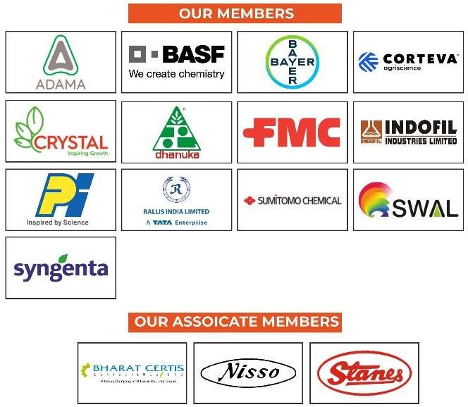

**For more information, contact:**

Mr. Joydeep Chakraborty Mobile: (0) 9711306346

E-mail: [communications@croplifeindia.org](mailto:communications@croplifeindia.org) Website: [www.croplifeindia.org](http://www.croplifeindia.org/)

**Follow CropLife India on –**

# Facebook | Twitter | Youtube | Instagram | Linkedin