PRESS RELEASE
Legalize recycling of properly rinsed and inspected empty pesticide containers – CropLife India Paper seeks a robust policy framework
Spearheads discussion on roadmap for sustainable management of empty pesticide containers in India

New Delhi, 26th May 2022: CropLife India, an association of 16 R&D driven crop science companies, and the leading voice of the plant science industry in India, organized a Virtual International Symposium on Empty Pesticide Containers (EPC) Management in India - Roadmap for Sustainable Management of Empty Pesticide Containers; which was attended by delegates from across the world including Asia, Europe and Africa.

A Discussion Paper - Roadmap for Sustainable Management of Empty Pesticide Containers was released on during the symposium by Dr. S. K. Malhotra, Chairman Registration Committee, Ministry of Agriculture & Farmers Welfare, Government of India; Dr. K. K. Sharma, Former Network Coordinator, All India Network Project on Pesticide Residues, Indian Agricultural Research Institute and other dignitaries.

Dr. S. K. Malhotra, Chairman Registration Committee, Ministry of Agriculture & Farmers Welfare, Government of India said, “There is an upsurge of demand for safe food crops. The industry has been forthcoming in registering newer and greener chemistries. In order to be sustainable, the concern of disposal of empty pesticide containers needs to be addressed collectively by all stakeholders hence lowering the burden on the environment”.

Dr. K. K. Sharma, Former Network Coordinator, All India Network Project on Pesticide Residues, Indian Agricultural Research Institute said, “As per the study conducted by the All India Network Project on Pesticide Residues, Indian Agricultural Research Institute; used pesticide containers should be rinsed three times thus making them safe to dispose and recycle in the country. The study results can be considered to support re-classification of triple rinsed empty pesticide containers in India as non-hazardous”.

Dr. Ravi Prakash, Plant Protection Adviser, Ministry of Agriculture & Farmers Welfare, Government of India said, “We feel that the formation of local collection points at the retailer level, where incentives can be provided to farmers to bring back empty rinsed containers is recommended. States should be given the responsibility to collect the containers, district-wise. Inter-Ministerial meetings are ongoing to develop SOP’s and other guidelines for disposing of hazardous wastes including pesticide plastics in a sustainable manner”.

Dr. Deepti Kapil, Scientist, HWMD, Centre Pollution Control Board said, “As per the CPCB guidelines, the generator of hazardous waste as well as the user have collective responsibility to manage and recycle the waste. The Government on its part has set up 200 waste management facilities with a capacity of 10 lakh tones but presently only 60,000 tones materials are being disposed of at these centers. The major problem is of regular collection and channelizing, which needs to be worked out at each district level in the country. As we move towards circular economy the focus should shift from end-of-treatment to end-of-use”.

Mr. Asitava Sen, Chief Executive Officer, CropLife India opines, "Establishment of collection and disposal of EPCs/Container Management is a step wise approach which requires strong support of the Government and coordination amongst multiple stakeholders. We reiterate that there is an imminent role of every

stakeholder in the value chain – government, manufacturers, channel partners, farmers, Producer Responsibility Organizations, recyclers and end-users. CropLife International, our parent organization; has successfully initiated and established independent Container Management Systems organizations and activities in 63 countries; which has removed over a million tonnes of agriculture waste plastic from the environment between 2005-2020”.

CropLife India has always been a constructive partner and a thought leader - initiating concrete dialogues and action plan involving all stakeholders - on emerging critical topics. Drone application for agriculture and agrochemical spraying, was one such topic, where CropLife India played the role of initiator and thought leader which eventually led to the Ministry of Agriculture and the Ministry of Civil Aviation opening up ‘Kisan drones’ sector, for quick adoption of this new technology for Indian farmers.

Mr. Sen added, “Sustainable Management of Empty Pesticide Containers involves a chain of activities consisting of collection, transportation, sorting, processing, recycling or disposal, among others. Our objective is to bring all concerned stakeholders on one platform, initiate dialogue and multi stakeholder engagement towards sustainable management of EPCs”.

Other eminent speakers who shared views and suggestions during the symposium included Dr. Andrew Ward, Stewardship Director, CropLife International; Mr. Simon-Thorsten Wiebusch, Executive Director, Bayer CropScience; Mr. Pierre de Lépinau, Director General, Adivalor (France); Ms. Yaping Liu, Executive Director, CropLife China; Mr. Friedrich Lüdeke Consultant and Trainer, GLOBAL G.A.P.; Mr. V. Ravichandran, Director, Global Farmer Network; Dr. Mathew Abraham, APAC Zonal Regulatory Program Leader, Corteva Agriscience India; Mr. Steven Byrde, Waste Management Consultant, CropLife International; Mr. Rahul V. Podaar, Managing Director, The Shakti Plastic Industries and Mr. Raju Kapoor, Director, Corporate Affairs, FMC India

Highlights of the Discussion Paper - Roadmap for Sustainable Management of Empty Pesticide Containers
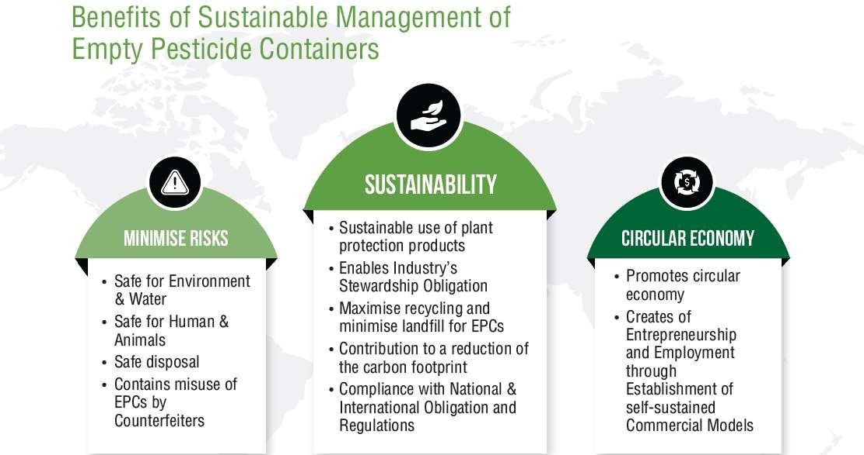
Primary pesticide packaging is essential to ensure safe handling, storage and application of agrochemicals throughout the value chain and beyond.
Post consumption of the pesticide these packs become waste (Empty Pesticide Container or EPC). Because of current pattern of use and management of pesticides, the volume of EPCs generated is increasing.

As pesticide containers are mostly produced from plastics, they contribute to the increasing mountain of plastic waste in India often dumped recklessly
into the environment, burned, or buried near farms. These discarded EPCs bear the risk of soil and ground water pollution owning to contamination with residuals of the pesticide and consequently can be hazardous for the community and the environment. The problem is further aggravated in view of their potential for misuse for storage of food and water in households.

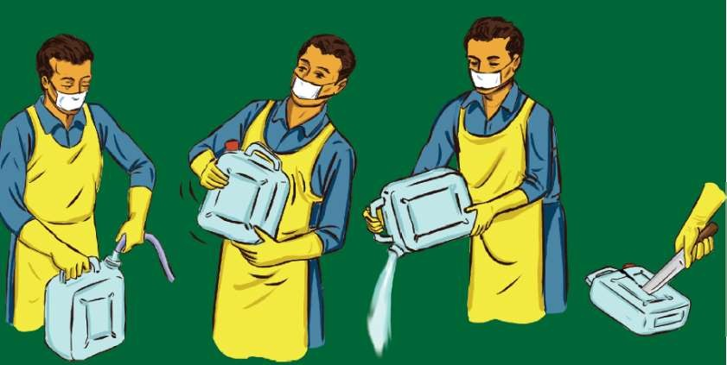
The International Code of Conduct of the distribution and use of agrochemicals (WHO/ FAO 2008) provides general guidelines on the management options for empty pesticide containers to minimize potential health and environmental impacts associated with their disposal. The FAO recommends triple-rinsing of EPCs as one effective practice for farmers to remove pesticide residuals from the containers. Cleaned pesticide containers
are classified in many countries as “non- hazardous” waste. The European Waste Catalogue suggests that where the hazardous component in the waste is less than 0.1 percent, the waste is no longer perceived as 'relevant' and the packaging is classified as “non-hazardous”. In Australia, triple rinsed containers are allowed to be recycled and classified as non-hazardous while containers that are not cleaned and properly rinsed are classified as hazardous waste.

The effectiveness of triple rinsing has been further demonstrated through a recent study undertaken by the All India Network Project on Pesticide Residues (AINPPR) of Indian Council of Agriculture Research, Government of India. The results indicate that irrespective of container type, formulation type, pack size, toxicity, etc., the pesticide residues tend to decline by > 99%. It is reasonable to expect that the remaining active ingredient content in waste composition after rinsing will serve as the basis to address classification criteria (toxicity) and the defined thresholds/cut-offs defined in the Waste Framework Directives.

This study is a balanced body of contemporary certainty, supplemented by research and analysis to enable the Indian Government to decide on a reclassification of decontaminated primary pesticide packaging in India and establish triple rinsing as a sustainable method for management of empty pesticide containers.

In February 2021, CIB&RC issued a public notice inviting comments from all stakeholders for classification of empty pesticide containers and disposal thereof. In response to the public notice, CropLife India had submitted a detailed seven-step roadmap for sustainable management of EPCs through shared responsibilities of all stakeholder considered. Further The 429th meeting of the Registration Committee held in June 2021 decided to formulate a working group/ task force comprising experts from DPPQ&S/CIB&RC, CPCB, State Governments, M/o EF&CC, ICAR and Pesticide industry associations stakeholders to work upon deciding the responsibility for collection and disposal of the empty container & suggest about linking/creation etc. of necessary infrastructures setup.

CIB&RC’s cognizance, and consideration to develop a framework for safe disposal of EPCs is therefore welcomed and perceived as a promising first step in the right direction to add India to this success story.

CropLife India hopes that the Ministry of Agriculture & Farmers Welfare (MoA&FW), Ministry of Environment, Forest & Climate Change (MOEF&CC), Central/ State Pollution Control Boards, Central Insecticide Board & Registration Committee (CIB&RC) and Industry can jointly facilitate a supportive mechanism to promote an effective empty pesticide container management system in India. CropLife India is highly motivated to support the process, as industry’s stewardship commitment.

About CropLife India:
CropLife India is committed to advancing sustainable agriculture and it is an association of 16 R&D driven member companies in crop protection and the leading voice of the plant science industry in India. We jointly represent ~ 70% of the market and are responsible for 95% of the molecules introduced in the country. Our member companies have annual global R & D spend of 6 billion USD and are firmly committed to engaging with the farming community to enable Safe, Secure Food Supply.
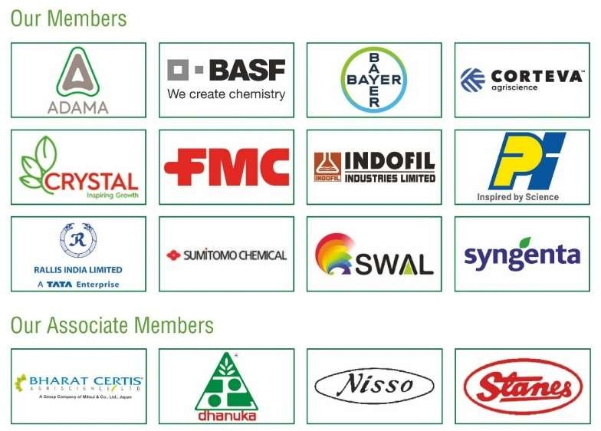

For more information, contact:
Mr. Joydeep Chakraborty Mobile: (0) 9711306346
E-mail: communications@croplifeindia.org Website: www.croplifeindia.org

Follow CropLife India on –
Facebook | Twitter | Youtube | Instagram | Linkedin

